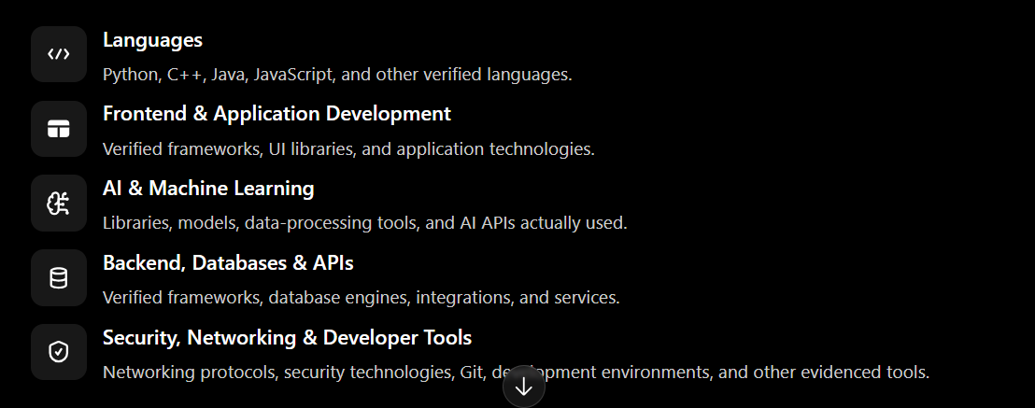
A. Main projects and application repositories
# | Repository name | Direct GitHub link
1 | ShieldPay | Open ShieldPay
2 | MediScript-AI-Project | Open MediScript AI
3 | Safar-AI-Smart-Route-Predictor | Open Safar AI
4 | CureOne-Unified-Healthcare-Management-System | Open CureOne
5 | cyber-crime-reporting-system | Open Cyber Crime Reporting System
6 | MBPLDS-DSA-Project- | Open MBPLDS
7 | Network-Controlled-Custom-CMD-Panel-Using-TCP-Sockets | Open TCP Sockets Project
8 | ShredX | Open ShredX
9 | Noshai-Steel | Open Noshai Steel
10 | ML — FlyRank internship | Open ML Repository
B. Contribution repositories — worked on with teammates
These links point to repositories owned by your collaborators, rather than your own GitHub account. The links alone do not establish which commits or pull requests you contributed.
# | Repository name | Owner | Direct link
1 | hit-and-check | AkifNaveed12 | Open repository
2 | Kairon | AkifNaveed12 | Open repository
3 | Schema-aware Synthetic Data Platform | AkifNaveed12 | Open repository
4 | AI Resume Analyzer | FarukhMumtaz | Open repository
5 | CyberCrime-IS | FarukhMumtaz | Open repository
C. Learning repositories and technical practice
# | Repository name | Direct GitHub link
1 | HTML-coding- | Open HTML Coding
2 | food-point | Open Food Point
3 | Java-Opp-Systems | Open Java OOP Systems
4 | C-Project | Open C Project
5 | AI-DataScience | Open AI & Data Science
6 | PYTHON | Open Python
7 | Web-Technologies | Open Web Technologies
8 | cyber-security-projects | Open Cybersecurity Projects
9 | Application-form | Open Application Form
10 | WebBasedUniversityPortal-UniveristyAssignment1 | Open University Portal
E. Your GitHub profile
GitHub Profile
github.com/hamzaali-712

LinkedIn Profile
Hamza Ali | LinkedIn

